**Bangladesh Army University of Science and Technology (BAUST), Saidpur**

Department of Computer Science and Engineering (CSE)



**LAB REPORT**

**Course Code:**

**Course Title:**

**Report No:**

**Report Tittle:**

**Comment:**

**Submitted By:**

**Name:**

**ID:**

**Level: Term:**

**Experiment Date:**

**Submission Date:**

**Submitted To:**

**Teacher Name:**

**Designation:**

**Teacher Name:**

**Designation:**

**Signature & Date: _________________**

1. **Objectives**

{**Instruction:** Write three to four points about the objectives of the experiment. Objectives should be listed point by point to clearly outline the goals of the specific lab work.}

**Example:**

1. To understand the concept and functionality of the "For Loop".
2. To explore the implementation of the "Break" statement in programming.
3. **Introduction**

{**Instruction:** Provide detailed information about the topics or mechanisms discussed during the lab. Include relevant background information, theoretical concepts, and their importance in the context of the experiment. Avoid overly technical jargon unless necessary, and aim for clarity.}

1. **Procedure**

**{Instruction:** Describe the steps undertaken to conduct the experiment. This section must include the following key subsections if applicable:

1. **Algorithm:** Write a structured list of steps in the algorithm.
2. **Flowchart:** Include a clear and labeled flowchart explaining the process.
3. **Detailed Procedural Steps:** Provide a detailed explanation of each step performed during the experiment.**}**

**Example Algorithm:**

**Experiment 1: Print all numbers from 1 to 100**

1. Start the program.
2. Initialize a variable i to 1.
3. Use a loop to iterate from 1 to 100.
4. Print the value of i.
5. Increment i.
6. Repeat steps 3-5 until i reaches 100.
7. End the program.

**Experiment 2****: Print all odd numbers from 1 to 100**

1. Start the program.
2. Initialize a variable i to 1.
3. Use a loop to iterate from 1 to 100.
4. Check if i is odd.
5. If true, print the value of i.
6. Increment i.
7. Repeat steps 3-6 until i reaches 100.
8. End the program.
9. **Required Hardware and Software:**

**{Instruction:** List all the hardware and software used during the experiment. Specify the versions and models wherever applicable for proper documentation.**}**

**Example**:

1. **Hardware**: Intel i5 Processor, 8GB RAM, Arduino UNO
2. **Software**: Python 3.10, Arduino IDE 1.8.13
3. **Experiment Implementation:**

**{Instruction:** Include the following elements in this section (if applicable):

**Codes:** Provide the source code written or used during the experiment. Ensure proper formatting and commenting for readability.

**Circuit Diagrams:** If applicable, include clear circuit diagrams. These should be labeled, and captions should describe their purpose in the experiment.**}**

**Example:**

**Experiment 1: Print all numbers from 1 to 100**

**Code:**

|  |
| --- |
| #include <stdio.h>  int main()  {  for (int i = 1; i <= 100; i++)  {  printf("%d\n", i);  }  return 0;  } |

**Output:**

**Table 1.1: Experiment 1 Output**

|  |  |  |
| --- | --- | --- |
| **Input** | **Expected Output** | **Actual Output** |
| NA | 1  2  3  ...  98  99  100 | 1  2  3  ...  98  99  100 |

**Experiment 2: Print all odd numbers from 1 to 100**

**Code:**

|  |
| --- |
| #include <stdio.h>  int main()  {  for (int i = 1; i <= 100; i+=2)  {  printf("%d\n", i);  }  return 0;  } |

**Output:**

**Table 1.1: Experiment 1 Output**

|  |  |  |
| --- | --- | --- |
| **Input** | **Expected Output** | **Actual Output** |
| NA | 1  3  ...  97  99 | 1  3  ...  97  99 |

1. **Discussion & Conclusion:**

{**Instruction:** Discussion section will contain:

1. Summarize the entire experiment, including the methods, results, and their implications.
2. Discuss any challenges faced during the experiment and how they were resolved.
3. Conclude with the key takeaways and how the experiment is beneficial for future applications.}
4. **References:**

**{Instruction:** List all the references used in preparing the lab report in a numbered format. Include books, websites, or any other sources**.**

**Format:**

1. Book_name by Book_author. (For Books)
2. Full URL of the website, access time and date. (For Websites)
3. Author name, Title and Year. (Format research article)}

**Example:**

1. "Introduction to Programming" by John Doe.
2. https://example.com/tutorial, accessed at 8.00 PM on 22nd January 2025.
3. E. Triantafillou, T. Zhu, V. Dumoulin, P. Lamblin, K. Xu, R. Goroshin, C. Gelada, K. Swersky, P.-A. Manzagol, et al., "Meta-Dataset: A Dataset of Datasets for Learning to Learn from Few Examples," 2019.

**GENERAL INSTRUCTIONS:**

1. Text Formatting rules:
   1. **Text Alignment:** Justified
   2. **Font:** Times New Roman (For Text)
   3. **Font:** Courier New (For Codes)
   4. **Font Size:** 12
   5. **Line Spacing:** 1.15
2. Codes can be presented in single or double column.
3. You must include Table No. and Table Caption on the top of the table (Center Align).
4. You must include Figure No. and Figure Caption on the bottom of the figure (Center Align).

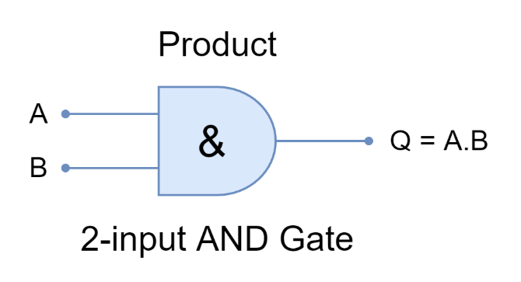For Figures:

**Figure 1.1: AND Gate Circuit**

For Tables:

**Table 1.1: Experiment 1 Output**

|  |  |  |
| --- | --- | --- |
| **Input** | **Expected Output** | **Actual Output** |
| NA | 1  3  ...  97  99 | 1  3  ...  97  99 |

1. You must cite every table and figure in the textual description of your report.